Does Thailand's economic growth drive pollution?

I. Introduction
Description
Does economic growth drive pollution? This question is particularly relevant in the case of Thailand, a country with rising economic ambitions yet limited environmental infrastructure. Over recent decades, Thailand has positioned itself as one of the key manufacturing hubs in Southeast Asia. With growing exports, foreign investment, and industrial output, the country’s economy has steadily expanded. However, this economic success may come at a cost.
From my perspective, Thailand still struggles with environmental awareness. Infrastructure gaps, weak enforcement of environmental policies, and limited public education contribute to a growing concern. Is Thailand’s economic development worsening its environmental footprint?
In this study, I aim to explore the relationship between carbon dioxide (CO₂) emissions and gross domestic product (GDP) per capita in Thailand. CO₂ emissions represent a core indicator of environmental degradation and are closely tied to energy consumption and industrial activity. On the other hand, GDP per capita is a common measure of economic progress and living standards. By analyzing whether higher income levels are associated with higher emissions, this study seeks to evaluate the cost of growth and whether the rise in business and productivity in Thailand is matched by rising pollution levels.
The results from this research could provide insights into whether Thailand's economic trajectory is sustainable and whether policy changes may be needed to ensure that growth does not come at the expense of environmental stability.
Method of Data Gathering
To examine the relationship between economic growth and pollution, this study utilizes secondary data from two reliable sources. The annual CO₂ emissions data (measured in metric tons) is collected from Worldometers.info, which compiles publicly available national emissions statistics. The GDP per capita data (in current US dollars) is sourced from the World Bank, one of the most trusted providers of global economic indicators.
The study spans the years 2000 to 2020, providing 21 years of annual data for both variables. This time frame ensures sufficient observations and captures a range of economic phases, including recovery from the Asian financial crisis, industrial expansion, and recent developments during the COVID-19 pandemic.
The data collected will be analyzed using the Spearman Rank Correlation Coefficient, a nonparametric test suitable for identifying monotonic relationships between two ranked variables. This method will help determine whether a statistically significant relationship exists between GDP per capita and CO₂ emissions in Thailand and in which direction that relationship leans.
II. Data Description
This study uses two key variables to explore the potential relationship between economic growth and environmental impact in Thailand: CO₂ emissions and GDP per capita, collected annually from the year 2000 to 2020.
Year | CO₂ emissions (A) | GDP per capita (B)
2000 | 174,387,930 | 1,846.9
2001 | 183,043,480 | 1,845.3
2002 | 194,527,630 | 2,000.7
2003 | 202,335,270 | 2,305.0
2004 | 220,476,730 | 2,639.1
2005 | 228,703,350 | 3,462.1
2006 | 232,210,690 | 3,952.9
2007 | 237,214,050 | 4,453.7
2008 | 238,304,810 | 4,768.6
2009 | 231,428,530 | 4,659.5
2010 | 245,683,200 | 5,453.2
2011 | 246,070,350 | 5,611.0
2012 | 264,101,970 | 5,978.0
2013 | 275,319,620 | 6,444.3
2014 | 271,735,200 | 6,436.7
2015 | 279,088,630 | 5,907.1
2016 | 275,376,690 | 6,049.9
2017 | 274,036,960 | 6,593.8
2018 | 271,250,960 | 7,273.0
2019 | 281,551,490 | 7,808.0
2020 | 274,299,090 | 7,233.6
reference: World of Bank and WorldOMeter
Variables Overview
- CO₂ Emissions (metric tons):
Represents the total annual carbon dioxide emissions produced within Thailand. It reflects the country’s level of industrial activity, energy consumption, and transport use. Data is sourced from Worldometer
- GDP per Capita (current US$):
Measures the average economic output per person, commonly used to reflect the standard of living. The data is retrieved from the World Bank.
Both variables are measured on a yearly basis and provide a consistent timespan of 21 observations. This meets the requirement for nonparametric analysis and ensures enough historical context for meaningful comparison.
III. Non-parametric Statistical Analysis
To evaluate the relationship between CO₂ emissions and GDP per capita in Thailand from 2000 to 2020, this section follows the five standard steps of hypothesis testing using the Spearman Rank Correlation Coefficient method.

Step 1: Hypothesis Setting Up
Let:
- Variable A: CO₂ emissions (in metric tons)
- Variable B: GDP per capita (in current US dollars)
H₀: There is no correlation between CO₂ emissions and GDP per capita in Thailand.
H₀: r_{s} ​= 0
Hₐ: There is a correlation between CO₂ emissions and GDP per capita in Thailand.
Hₐ: r_{s} ​≠ 0 (two-tailed test)
Step 2: Significance Level
The significance level 5%, α=0.05
Step 3: Select the non-parametric test
The Spearman Rank Correlation Coefficient is chosen for this analysis because it is a nonparametric method that does not require the assumption of normal distribution, making it suitable for real-world economic and environmental data that may not meet parametric conditions. It is ideal for measuring the strength and direction of a monotonic relationship between two continuous variables, in this case, CO₂ emissions and GDP per capita. Given the small to moderate sample size (n = 21) and the goal of identifying whether a consistent ranking pattern exists between economic growth and pollution, this test offers both flexibility and statistical reliability
Step 4: Decision Rule
To find the critical value, t_{α},_{v} we must first identify the significant level and the degree of freedom.
- Significant Level (α) = 5% = 0.05
- Degree of Freedom (v) = n − 2 = 21 − 2 = 19
From the hypothesis statement setup, this is a two-tailed test. Therefore, we find the critical value: ±t_{α/2,v} = ±t_{0.05/2,19} = ±t_{0.025,19}
From the t-table: t_{0.025,19} = 2.093 -t_{0.025,19} = -2.093

Draw t-curve:
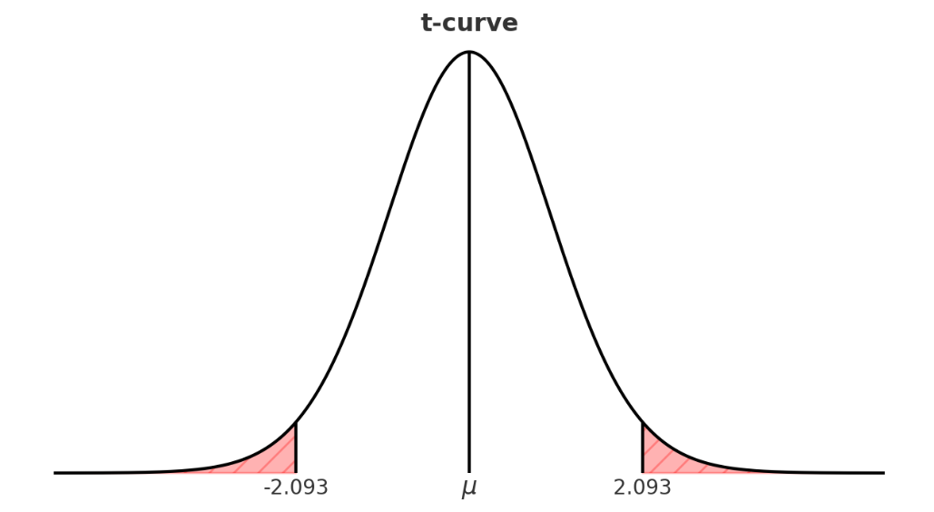
The null hypothesis can be rejected if the absolute value of the test statistic is greater than 2.093. In other words, if: ∣t∣ > 2.093
Step 5: Make a Decision
Year | CO₂ emissions (A) | GDP per capita (B) | Rank A | Rank B | d (a-b) | d²
2000 | 174,387,930 | 1,846.9 | 21 | 20 | 1 | 1
2001 | 183,043,480 | 1,845.3 | 20 | 21 | -1 | 1
2002 | 194,527,630 | 2,000.7 | 19 | 19 | 0 | 0
2003 | 202,335,270 | 2,305.0 | 18 | 18 | 0 | 0
2004 | 220,476,730 | 2,639.1 | 17 | 17 | 0 | 0
2005 | 228,703,350 | 3,462.1 | 16 | 16 | 0 | 0
2006 | 232,210,690 | 3,952.9 | 14 | 15 | -1 | 1
2007 | 237,214,050 | 4,453.7 | 13 | 14 | -1 | 1
2008 | 238,304,810 | 4,768.6 | 12 | 12 | 0 | 0
2009 | 231,428,530 | 4,659.5 | 15 | 13 | 2 | 4
2010 | 245,683,200 | 5,453.2 | 11 | 11 | 0 | 0
2011 | 246,070,350 | 5,611.0 | 10 | 10 | 0 | 0
2012 | 264,101,970 | 5,978.0 | 9 | 8 | 1 | 1
2013 | 275,319,620 | 6,444.3 | 4 | 5 | -1 | 1
2014 | 271,735,200 | 6,436.7 | 7 | 6 | 1 | 1
2015 | 279,088,630 | 5,907.1 | 2 | 9 | -7 | 49
2016 | 275,376,690 | 6,049.9 | 3 | 7 | -4 | 16
2017 | 274,036,960 | 6,593.8 | 6 | 4 | 2 | 4
2018 | 271,250,960 | 7,273.0 | 8 | 2 | 6 | 36
2019 | 281,551,490 | 7,808.0 | 1 | 1 | 0 | 0
2020 | 274,299,090 | 7,233.6 | 5 | 3 | 2 | 4
Total |  |  | 231 | 231 | 0 | 120

Spearman Rank Correlation Coefficient
t-test for significance of r_{s} t = $\frac{r_{s}\sqrt{n-2}}{\sqrt{1-r^{2}}}$
but r_{s} = 1 - $\frac{6\sum{d^{2}}}{n(n^{2}-1)}$
This project is being conducted by using the secondary data of CO₂ emissions and GDP per capita of Thailand from (source, 2023). This topic research will be analyzed based on the data from the year 2000 until the year 2020, totaling 21 years.
Sample size n = 21
$\sum{d^{2}}$ = 120
r_{s} = 1 - $\frac{6\sum{d^{2}}}{n(n^{2}-1)}$
r_{s} = 1 - $\frac{6 x 120}{21({21}^{2}-1)}$
= 0.9221
Test Statistic = t-test: $\frac{0.9221x\sqrt{21-2}}{\sqrt{1-{(0.9221)}^{2}}}$ ≈ 8.93

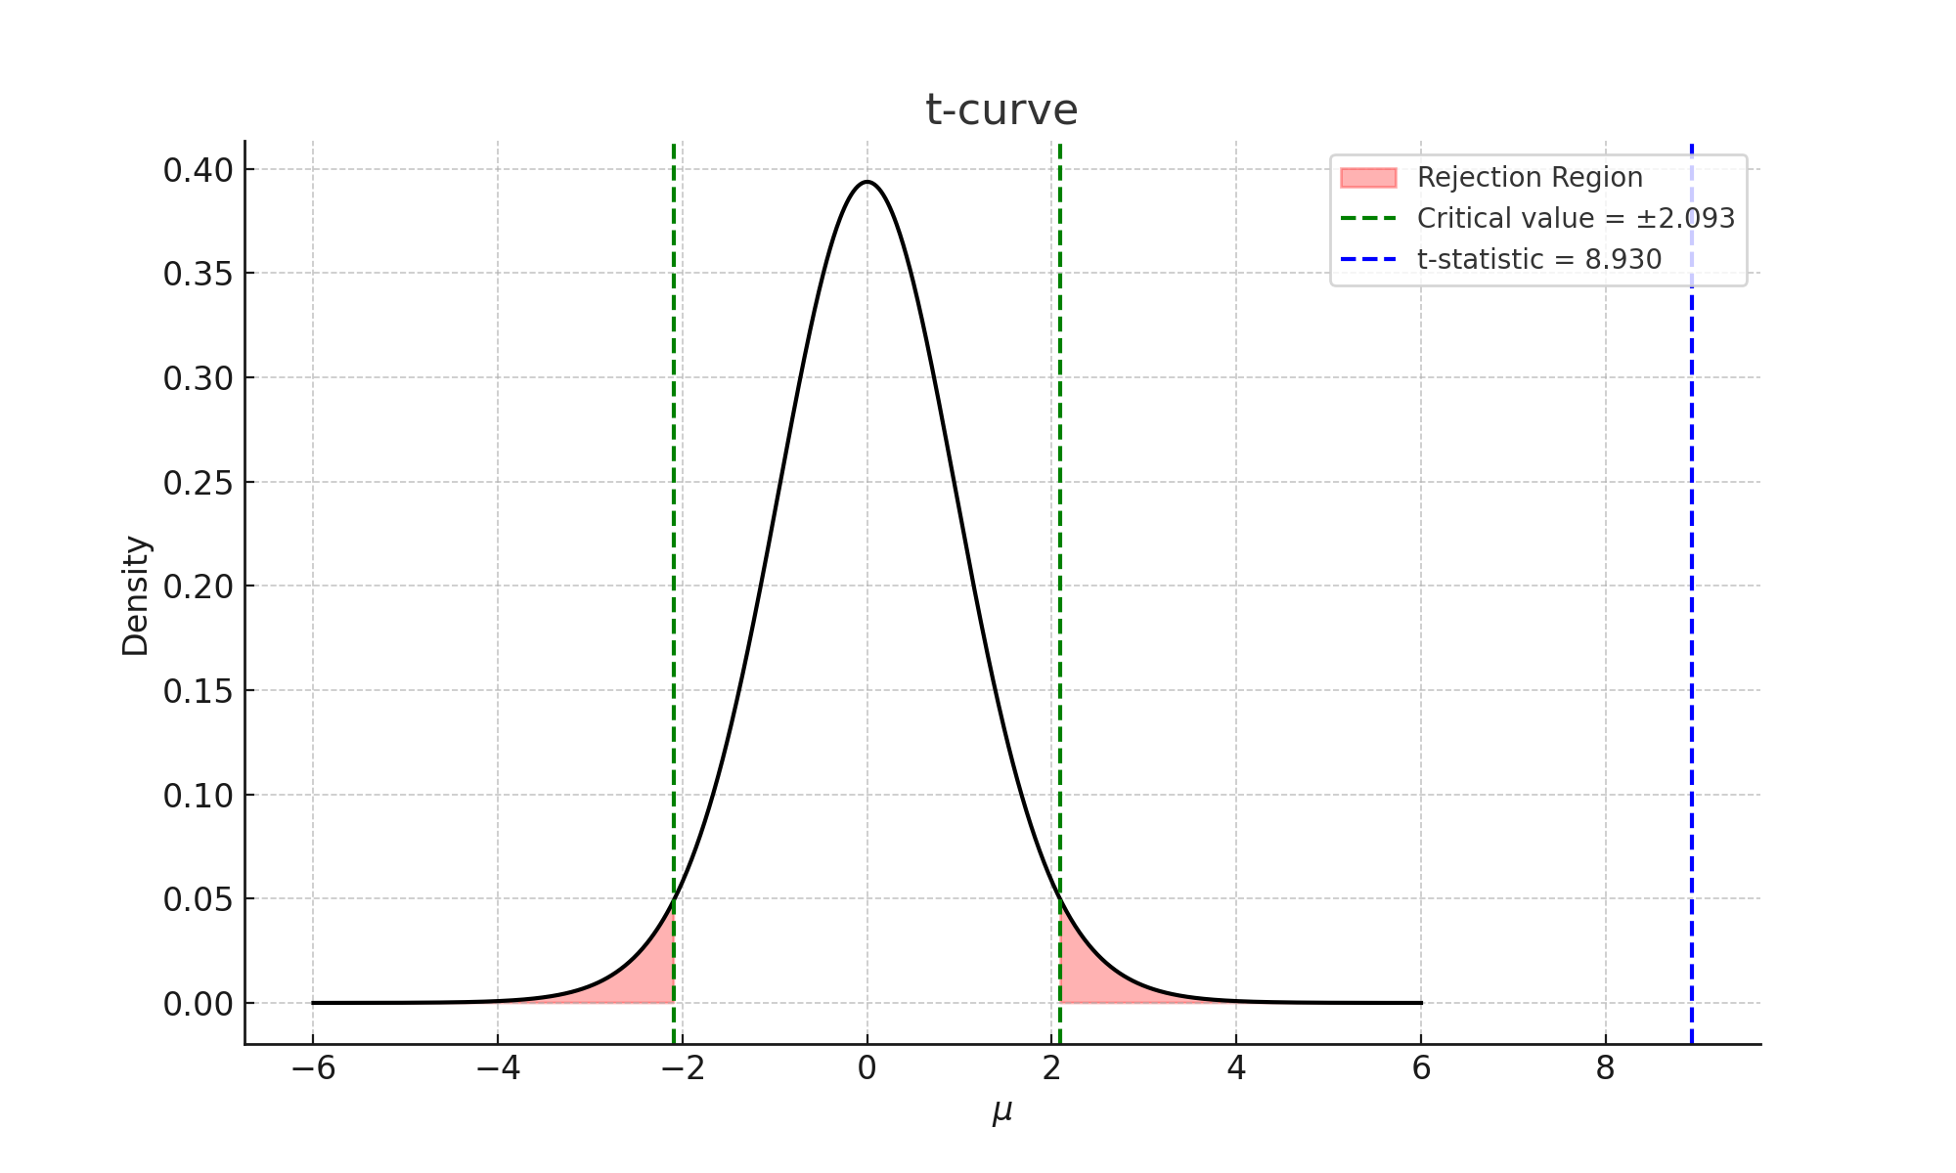
Based on the t-curve, we can see that the value of the t-statistic, which is approximately 8.93, is located far in the rejection area. That is, the test statistic t = 8.93 is greater than the critical value from the t-table t_{0.025,19} = 2.093. Since the test statistic lies outside the acceptance region, we can reject the null hypothesis at the 5% significance level. This result provides sufficient evidence to confirm that there is a statistically significant relationship between the two variables under study.
IV. Conclusion
By running the Spearman Rank Correlation Coefficient related to the topic of “Test the relationship between CO₂ emissions and GDP per Capita”, case in Thailand, we have enough evidence to prove that there is a correlation between these two variables. From this result, we can draw the conclusion that carbon emissions have a significant association with the economic growth of Thailand.
Based on the calculation, the Spearman correlation coefficient, r_{s} has a value of 0.9221, which indicates a strong positive correlation between CO₂ emissions and gross domestic product per capita. This suggests that economic growth in Thailand over the past two decades has been closely linked to increased carbon emissions. The findings reflect that as GDP per capita has risen, environmental pollution has also intensified.
Studying this topic can be beneficial to economics students, environmental agencies, and policymakers. It should be noted that observations of higher GDP per capita levels are strongly associated with higher levels of CO₂ emissions. This raises concerns about the sustainability of Thailand’s economic development and whether enough measures are being taken to address environmental degradation. If economic growth continues without effective environmental regulation, it could lead to long-term ecological damage and social costs.
In conclusion, CO₂ emissions and GDP per capita show a strong positive correlation in the case of Thailand. This result can be applied more broadly to reflect on how economic growth in developing and industrializing nations may contribute to rising environmental challenges. The government, together with the private sector, should take these findings seriously and implement policies that promote cleaner production, renewable energy, and sustainable practices to ensure that economic development does not come at the cost of environmental well-being.
Finally, I hope that this non-parametric project contributes to raising awareness of the relationship between economic activity and environmental impact. It is important that this relationship continues to be studied and monitored to support balanced and sustainable national development.

